|  |  |  |  |  |  |  |  |  |
| --- | --- | --- | --- | --- | --- | --- | --- | --- |
| **1** |  | **INTRODUCTION** |  | | | |  |  |
|  |  | * 1. Overview   The project is an Intelligent Customer Help Desk with Smart document understanding. While the usual customer care chatbots help find the nearest store, book appointments or even tell you the working hours, this smart desk will also solve your queries regarding the products you have purchased with the help of smart document handling. |  | | | |  |  |
|  |  | * 1. Purpose   It helps reduce the burden on call center representatives as a lot of simple queries would be solved by the bot itself and would not require human intervention. Thus, they will be able to revert more time to other more beneficial purposes. |  | | | |  |  |
| **2** |  | **LITERATURE SURVEY** |  | | | |  |  |
|  |  | 2.1 Existing problem  The problem existing in the current scenario is the lack of representatives in customer care unit thereby increasing the delay and testing the patience of numerous customers. This in turn has the risk of even bringing down the company in the name of poor customer service. | | | | |  |  |
|  |  | 2.2 Proposed solution  The solution proposed is that a simple bot that can help give information about the store and products and also clear the doubts and issues they have regarding the purchased product with the help of document understanding from the user manual or trouble shooting manual. This is done by training the bot with potential doubts that could be raised by customers and their desired answers. | | | | |  |  |
| **3** |  | **THEORITICAL ANALYSIS** |  | | | |  |  |
|  |  | 3.1 Block diagram |  | | | |  |  |
|  |  | 3.2 Hardware / Software designing  The software technologies used for designing the bot were:   1. Watson Assistant- The chatbot was developed using intents and entities and setting up a dialog flow and further using a webhook to the Watson Discovery service. The intents and entities are made by training the assistant with a lot of possible or similar words and questions. 2. Watson Discovery- The user manual was split into a number of documents based on subtitles and the service was trained to differentiate between text, titles, subtitles, tables, etc. 3. IBM Cloud functions- This helped create the webhook to be used in the assistant by creating a node js file. 4. Node-Red- Node red was used to integrate all the services used and display the results on a web dashboard(user interface). | |  |  |
| **4** |  | **EXPERIMENTAL INVESTIGATIONS** | | | | |  |  |
| **5** |  | During the course of the internship, I could find out the usefulness of the IBM Cloud. I had also tried using Watson Insights feature for sentiment analysis.  **FLOWCHART** |  | | | |  |  |

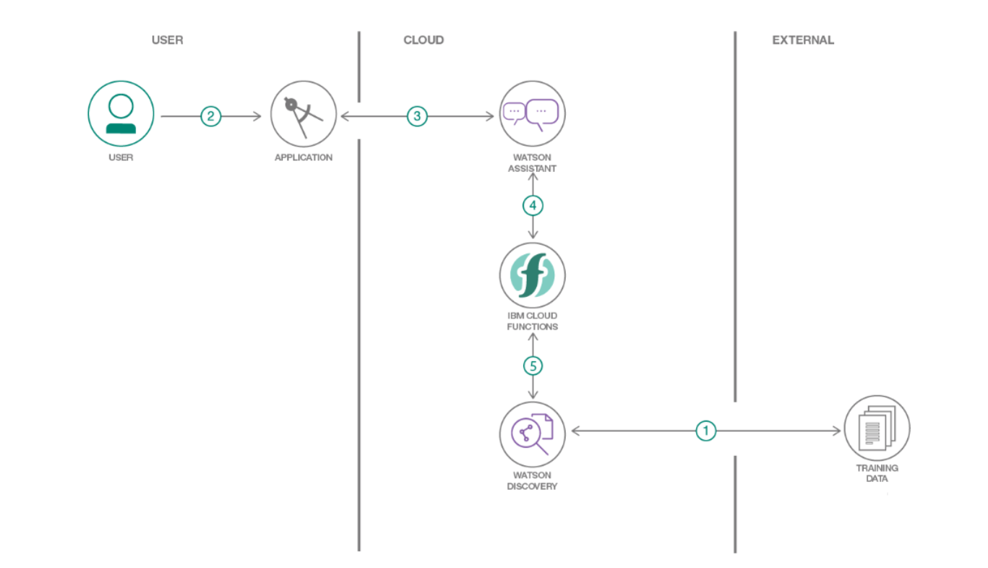

1. **RESULT**

A smart document handling customer help desk that answers the customers questions without transferring the conversation to a human representative from a pre-trained document.

1. **APPLICATIONS**

This bot can be used in a help desk or a restaurant or even as an AI Recruiter after having trained it accordingly and feeding it with pre-determined expected answers and then comparing the answers given by the candidate.

Another application could be in creating mood enhancers.

1. **CONCLUSION**

I would like to conclude my report on the note that the project has been successfully completed within a time span of 23 days. The objectives were met and a fully functional web dashboard consisting of a chatbot was delivered.

1. **FUTURE SCOPE**

The spectrum of uses for this product is unlimited and can hence be extended to any domain that requires human interaction with a prior knowledge about something. This could also be developed to show videos as a reply to queries from checking the transcript of videos to find relevant information.

1. **BIBLIOGRAPHY**
2. <https://www.youtube.com/watch?v=hitUOFNne14> -Creating Watson Assistant
3. <https://developer.ibm.com/components/watson-assistant/series/learning-path-watson-assistant>
4. <https://www.youtube.com/embed/G3bqRndQtQg> -Creating Cloud functions
5. <https://developer.ibm.com/tutorials/how-to-create-a-node-red-starter-application> -Node-Red tutorial